**CTEC 402: In Class_ Assignment2**

Part 1: You need Explore the Real-time Network Monitoring (5 points)

1. Software1: Here is URL for more information “ManageEngine OpManager (FREE TRIAL) A package of network and server monitoring services that is available in free and paid versions. Installs on Windows”

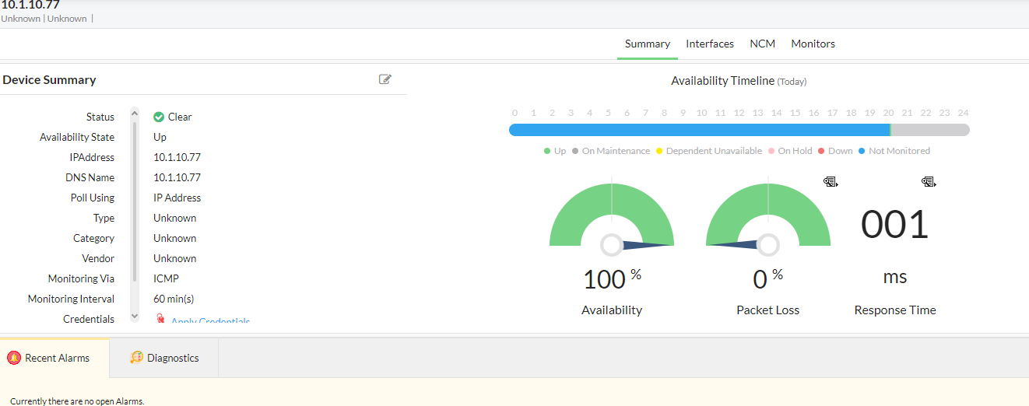**Summary**: The device with IP address 10.1.10.77 is up and running with 100% availability, no packet loss, and a minimal response time of 1 millisecond. The device is being monitored via ICMP every 60 minutes, and there are no current alarms or issues.

1. Software2: Here is URL for more information “Datadog Network Performance Monitoring provides full visibility into every network component that makes up your on-prem, cloud, and hybrid environments, with little to no overhead. By monitoring the performance of connections among your hosts, services, virtual private clouds (VPCs), and other elements, you can quickly determine when your network is the root cause of any issue.”

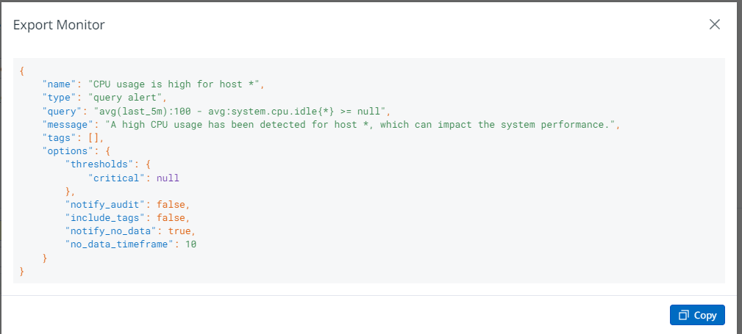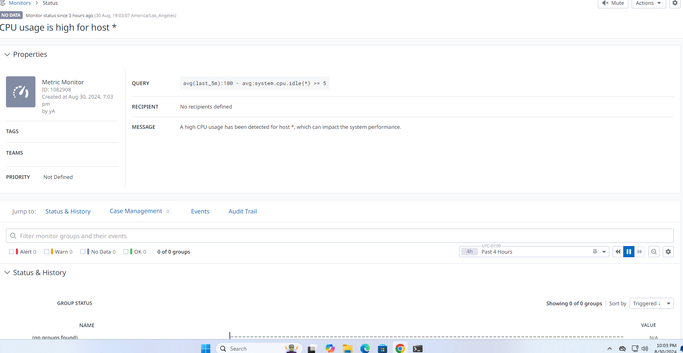**summary**: High CPU usage means that your computer's processor is working at or near its maximum capacity, which can cause significant slowdowns in system performance. When the CPU is overburdened, applications may respond slowly or become unresponsive, leading to lag and delays in completing tasks. Additionally, high CPU usage can cause the system to overheat, as the processor generates more heat when it’s working hard. This overheating can trigger thermal throttling, where the CPU reduces its speed to cool down, further slowing down the system.

1. Software3: Here is URL for more information “Domotz is a network monitoring software designed for IT professionals and MSPs.

**Part 2: ChatGPT Assignment (10 points)**

First write your OWN words. Next, using the new AI ChatGPT, ask it the same question(s) and edit the responses down to 100 words. You can create a chart to show your work and ChatGPT side-by-side. Make sure in your answers you reference the readings.

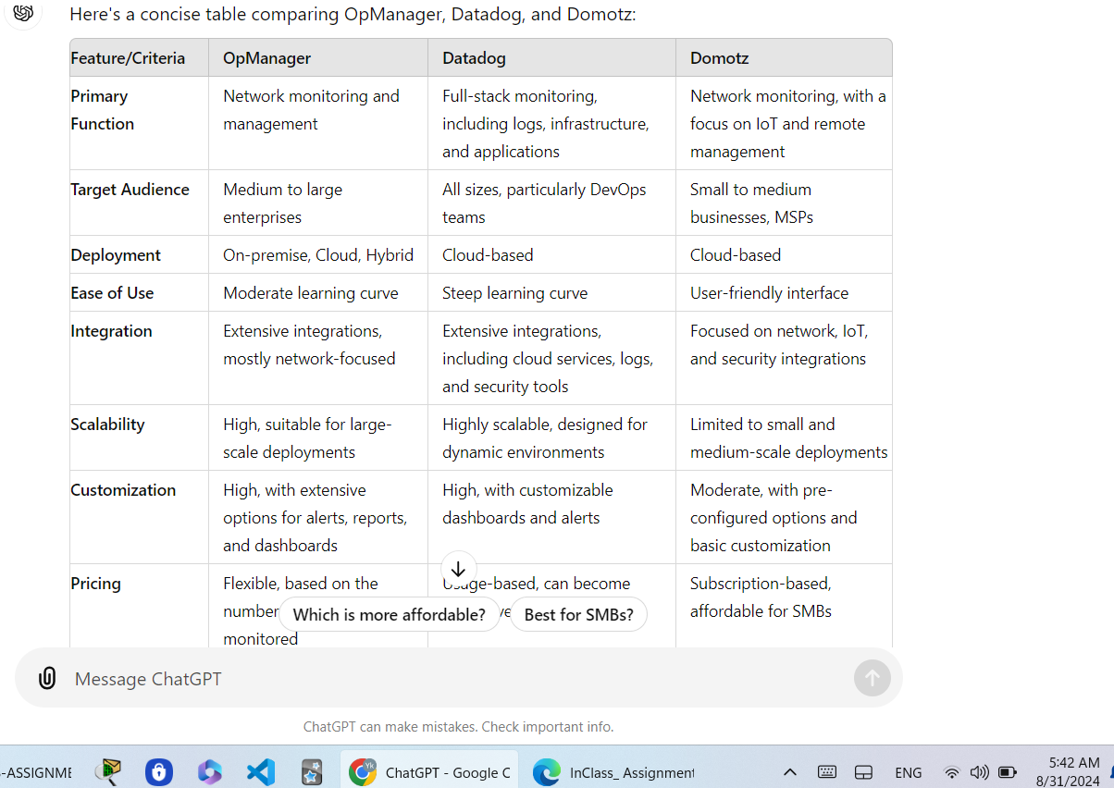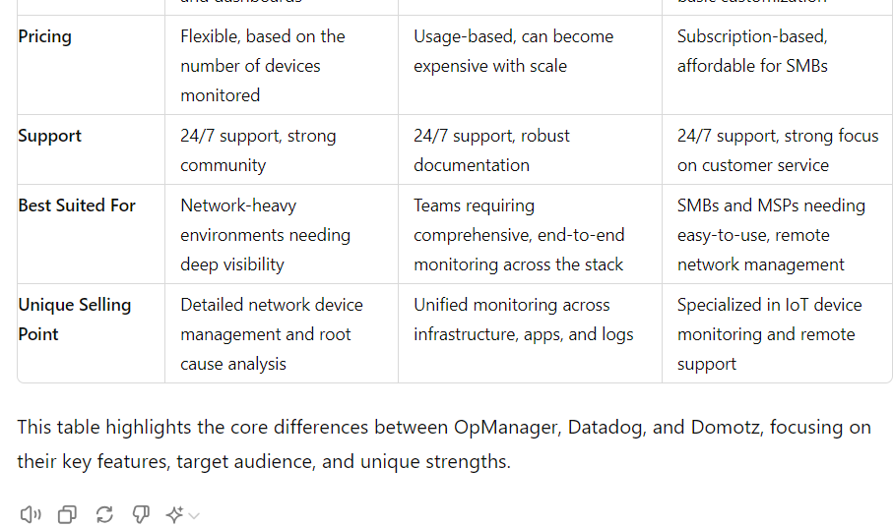My personal summary:

* **OpManager** is an essential networking management tool used by enterprises to troubleshoot various device issues, including routers, switches, servers, firewalls, and other end-user devices. It offers features such as network topology mapping, real-time alert notifications, analysis of different network components, real-time performance analysis, and much more**.**
* **Datadog:** Unlike OpManager, Datadog covers a wide range of activities including cloud infrastructure monitoring, application performance monitoring, log management analysis, and more. It is the preferred choice for organizations that require in-depth analysis of their IT infrastructure status, comprehensive reporting, and a clear overview of system performance during monitoring.
* **Domotz:** Unlike other monitoring tools, Domotz is important for remote troubleshooting and network management. The choice depends on which issue is a priority for the organization.

**Part three: How to Video**